

**AUSTRALIAN LACE GUILD**

ACN 006 462 175

**National Conference and Workshops**

**Registration Form**

21-28 September 2025

McLaren Vale Apartment and Conference Centre

Main Rd & Caffrey St, McLaren Vale SA 5171

|  |  |  |  |  |  |  |  |  |  |  |  |  |  |  |  |  |
| --- | --- | --- | --- | --- | --- | --- | --- | --- | --- | --- | --- | --- | --- | --- | --- | --- |
| **YOUR DETAILS – BLOCK LETTERS PLEASE** | | | | | | | | | | | | | | | | |
| TITLE: | SURNAME: | | | | GIVEN NAMES | | | | | | PREFERED NAME FOR NAME BADGE | | | | | |
| ADDRESS: | | | | | | | | | | | MEMBERSHIP NO.:  Tick for non-member | | | | | |
| Mobile No.: | | | | | EMAIL ADDRESS | | | | | | | | | | | |
| **REGISTRATION** | | | | | | | | | | | | | | | | **Amount** |
| REGISTRATION | | EARLY BIRD REGISTRATION  MUST BE RECEIVED  BEFORE 15 July | | | | | REGISTRATION  AFTER15 July | | | | | | | | |  |
| MEMBER | | NON-MEMBER | | | **MEMBER** | | | **NON-MEMBER** | | | | | |
| FULL Conference | | $50 | | $75 | | | $75 | | | $100 | | | | | |
| PARTIAL REGISTRATION COST PER DAY | | $10 | | $15 | | | $15 | | | $20 | | | | | |
| INDICATE DAYS:___Mon. ___Tues. ___Thurs. ___ Fri. ___ Sat.__AGM Only (no Cost) | | | | | | | | | | | | | |
| **Facility and Food(MT, Lunch, AT and continuous coffee and tea) required for everyone** | | | | | | | | | | | | | | | | |
| Full Week | | | | | | | | | | | | | $370 | | |  |
| Daily | | | | | | No of days from above | | | | | | | $ 75 | | |
| **WORKSHOPS** please number 1 to 3 with 1 being your first preference Decisions on which workshops will run by 31 July | | | | | | | | | | | | | | | | |
|  | **Oak Leaves and Acorn** (Slovenian Lace Techniques) | | | | | **Simona Strgulc Krajšek** | | | 4 days | | | | | $410 | |  |
|  | **3-D Tatting** | | | | | **Gaye Beswick** | | | **4 days** | | | | | **$410** | |
|  | **3-D Tatting** | | | | | **Gaye Beswick** (Mon-Tues) | | | 2 days | | | | | $210 | |
|  | **3-D Tatting** | | | | | **Gaye Beswick** (Thu-Fri) | | | 2 days | | | | | $210 | |
|  | **Advanced Torchon** | | | | | **Christine Johnson** | | | **4 days** | | | | | **$410** | |
|  | **Reticella Needle Lace** | | | | | **Di Kirchner** | | | **4 days** | | | | | **$410** | |
|  | **Reticella Needle Lace** Christmas Decoration | | | | | **Di Kirchner** (Mon-Tues) | | | 2 days | | | | | $210 | |
|  | **Reticella Needle Lace** Bookmark | | | | | **Di Kirchner** (Thu-Fri) | | | 2 days | | | | | $210 | |
|  | **Schneeberg Lace** | | | | | **Brigitta Keane**  (Mon-Tues) | | | **2 days** | | | | | **$210** | |
|  | **Lace Making Off The Grid** | | | | | **No longer offered** | | |  | | | | |  | |
|  | Social Lace | | | | |  | | | 4 days | | | | | $ 0 | |
| **WELCOME DINNER** Sunday 21 September | | | | | | | | | | | | | | | | |
| A light meal prepared by SA Members Sunday night | | | | | | | | | | | | | | $20 | |  |
| **GALA DINNER** SATURDAY 27 SEPTEMBER | | | | | | | | | | | | | | | | |
| Cost is per person. Please indicate number if for more than one person | | | | | | | | | | | | | | | $70 |  |
| **CONFERENCE BOBBINS** | | | | | | | | | | | | | | | | |
| 2025 Conference Bobbin by John Beswick number | | | | | | | |  | | | | $10 | | | |  |
| **Wednesday Tour** | | | | | | | | | | | | | | | | |
| Details on the next Page cost $90 | | | | | | | | | | | | | | | |  |
| Total | | | | | | | | | | | | | | | |  |
| Dietary requirements | | |  | | | | | | | | | | | | | |

**Kits for workshops** and costs will be detailed in the class requirements which will be sent out after July 21.

**Lace Pillow:** Please indicate here if you need to borrow a lace pillow: _______________________

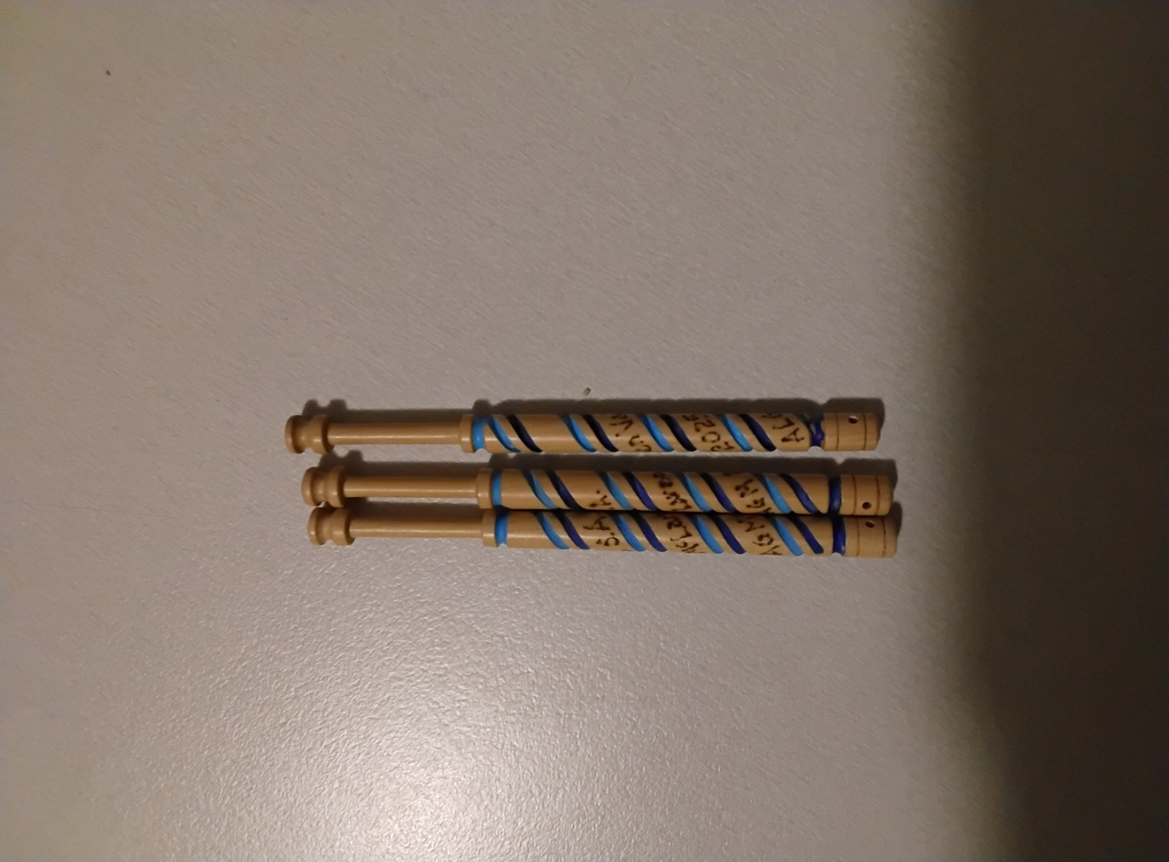**Conference Bobbin** by John Beswick pictured below.Please order the number you require on Pg1

**Adelaide Transfers:** South Australian members have volunteered to transport anyone arriving in Adelaide to the venue and back to Adelaide. Tina Clogg will be organizing this. The NAC believe that a reasonable contribution towards car expenses is $20 per person each way. (We have to be careful not to make this a “taxi” service for all sort of legal reasons.) Please indicate below if you require this.

Arriving: Airport or _______________ Date: _________________ Time __________ am/pm

Departing: Airport or _______________ Date: _________________ Time __________ am/pm

**Accommodation information on the next Page.**

Do you want help to organize someone to share accommodation with you? Yes____No_____

Sharing With_______________________________________________________

**Wednesday Tour Cost**

8:30 Departure Conference Centre

9:15 **ALG SA Lace House**

View lace display and Morning Tea

10:15 **SA Embroiderer’s Guild**

Talk including slide show of some of their needle lace and time in the gallery

12:15 **St Augustine’s Church Unley**

A short talk on the William Morris Stained Glass Windows and time to view the windows and Lunch

William Morris a designer, craftsman and decorator, is considered amongst the greatest pattern makers of all times. His highly skilled group produced superior stained glass.

St Augustine’s Unley 14 significant William Morris stained glass windows, of which 12 were made at the premises of Morris and Co, at the Merton Abbey Works, London. These windows were all donated between 1928 and 1948, many donations by founding colonists or their children. The stories in these windows depict these colonists’ endurance, commitment and passion, not only for life, but for their faith.

1:45 **Carrick Hill Guided Tour at 2:00**

Carrick Hill is fortunate to be one of the few period homes in Australia to survive with its original contents almost completely intact and its grounds undiminished.

Previously the private home of Sir Edward and Ursula Hayward, Carrick Hill is now for everyone to enjoy. Find out more about the estate’s unique history, its evolution from country home to national treasure, and its enduring importance today. Carrick Hill is a cultural and heritage icon, known for its historical significance. The heritage value of the site as a whole is a complex fabric of social history, family lore, land stewardship, a passion for horticulture, and a gift for doing business, all woven together. For more information: <https://www.carrickhill.sa.gov.au/>

4:00 Depart for the Conference Centre arriving about 4:45

**Accommodation available at the McLaren Vale Apartments:**

All accommodation is to be booked directly with the Apartments on phone number: 08 8323 8265 with a $50 deposit. Make sure you tell them you are part of the Australian Lace Guild Conference from 21 September to 28 September.

A **continental breakfast** in the rooms is available for $18 per person per day and **must be requested at the time of booking.**

 Available rooms:

10 **Queen rooms** ( 2 beds x 2 pax) $175

All other rooms are $175 if occupied by one person or

                                   $250 if shared to a max of 4 people.

If a person 5th shares there is an additional cost of $30.

**Rooms available on first come basis**

5 **Executive Deluxe** (1 bed x 1 pax - can add another bed)

5 **Two bedroom units** (5 beds x 5 pax)

4 **Family rooms** (3 beds x 3 pax)

2 **King Deluxe Apartments** (3 bed x 3 pax)

10 **Studio Deluxe Apt** (1 bed x 1 pax - plus sofa bed in room

**Motel Cancellation Policy:** Cancellation at no charge up to 48 hours before the conference.

**Cancellation Policy:**

**Before 15 July:** FULL REFUND

**Between 16 July and 10 September:** 50% minus Admin Fee $100

**After 10 September:** No Refund

You need to consider travel insurance.

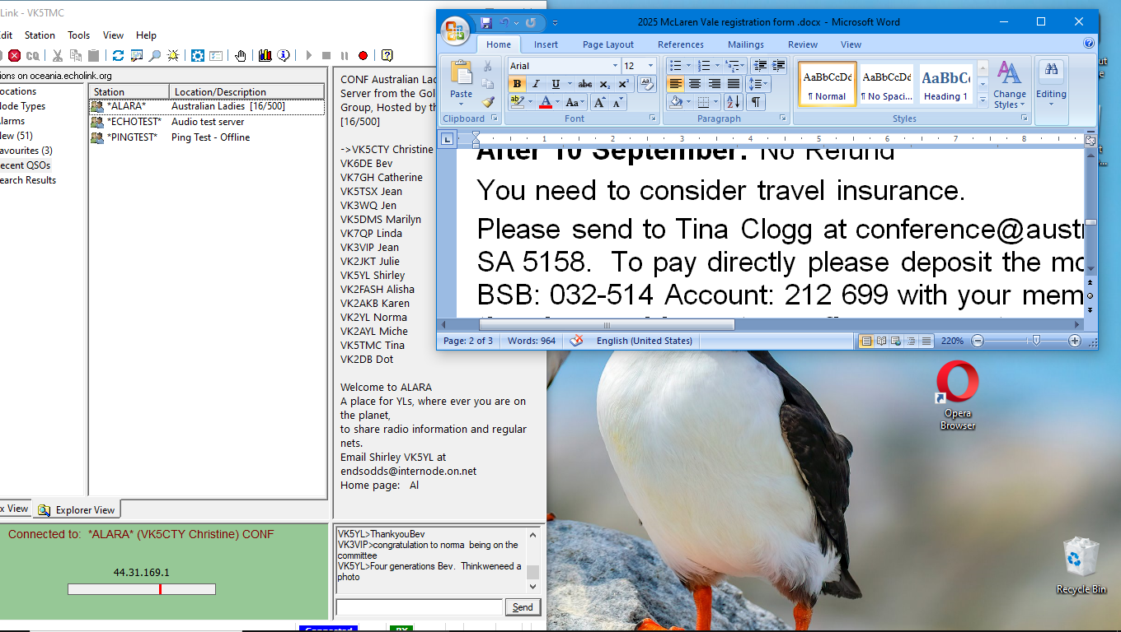Please send to Tina Clogg at conference@australianlaceguild.com.au or PO Box 78, O’Halloran Hill SA 5158. To pay directly please deposit the money to: Australian Lace Guild Conference Account with your membership no. or name as the reference and **email to the above address to confirm payment.**